EXPERIMENT NO. 25

Creating a GitHub Repository and Updating the README File

Aim
To create a new GitHub repository, initialize it with a README.md file, clone it to the local machine, update the README, and push the changes back to GitHub using Git.

Software Requirements
- Windows 10/11 (or Linux/macOS)
- Git
- GitHub Account
- Visual Studio Code (or any code editor)

Theory
Git is a distributed version control system used to manage source code changes. GitHub is a cloud platform for hosting Git repositories. A repository can be cloned to a local machine, where changes are made and tracked using Git. After committing the changes, they are pushed to the remote repository on GitHub, ensuring that both local and remote repositories remain synchronized.

Procedure
Step 1: Create a GitHub Repository
- Log in to GitHub.
- Click New Repository.
- Enter the repository name.
- Select Public or Private.
- Check Add a README file.
- Click Create Repository.
Step 2: Clone the Repository
Open Git Bash or Terminal.
git clone https://github.com/YourUsername/RepositoryName.git

Move to the repository folder.
cd RepositoryName

Step 3: Open the Project
Open the repository in Visual Studio Code.
code .
Step 4: Edit the README File
- Open the README.md file.
- Add a project title and description.
Example:
# Personal Project
This project demonstrates Git and GitHub version control operations.

Save the file.
Step 5: Check the Repository Status
git status

Step 6: Stage the Changes
git add README.md

Step 7: Commit the Changes
git commit -m "Updated README with project description"

Step 8: Push the Changes
git push origin main

If the default branch is master, replace main with master.
Step 9: Verify the Changes
- Open the repository on GitHub.
- Refresh the page.
- Verify that the updated README.md file is displayed.

Screenshots

Before:-

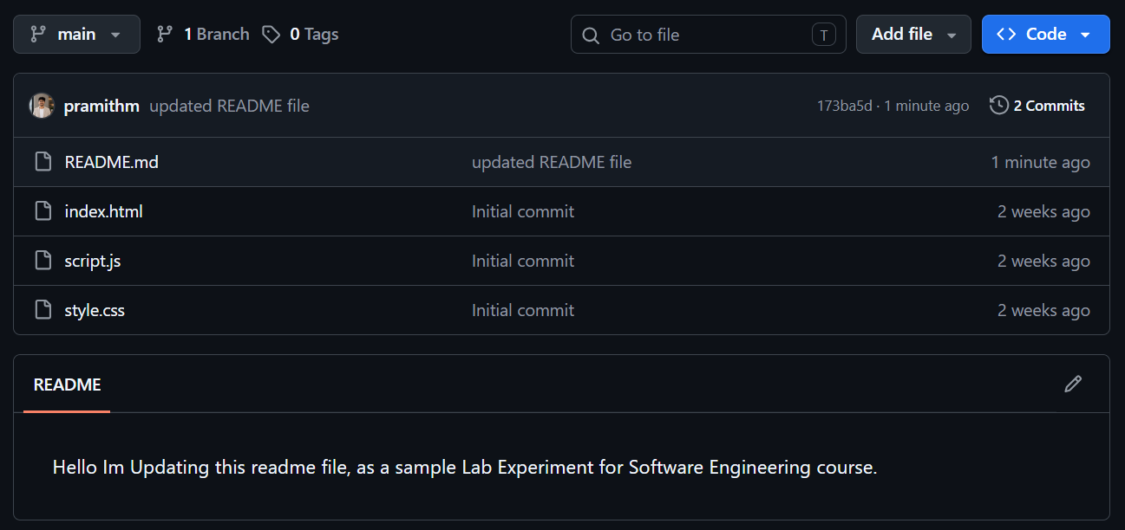
After:-

Observation
- GitHub repository was created successfully.
- Repository was cloned to the local machine.
- README.md file was updated successfully.
- Changes were staged, committed, and pushed to GitHub.
- The updated README was visible in the GitHub repository.

Result
A new GitHub repository was successfully created and initialized with a README.md file. The repository was cloned locally, the README was updated with a project description, and the changes were committed and pushed successfully to GitHub.

